**Pre-Operative Bathing**

**Bathing prior to your child’s surgery**

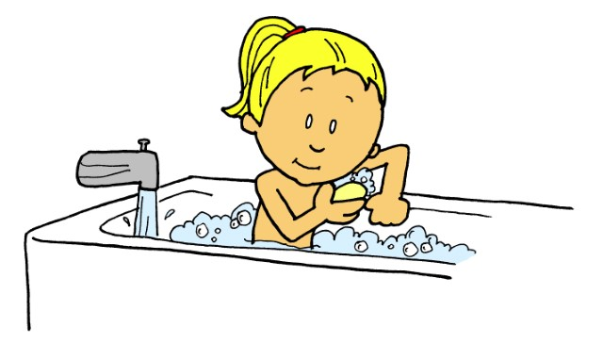

Your child is scheduled for a surgical procedure. Before surgery, you can play an important role in your child’s health to reduce infection. You can reduce the number of germs on your child’s skin through careful washing and bathing. Your child will need to bathe or shower the night before using regular soap. Depending on the surgery, your child may not be able to take a bath/shower with soap and water for a few days.

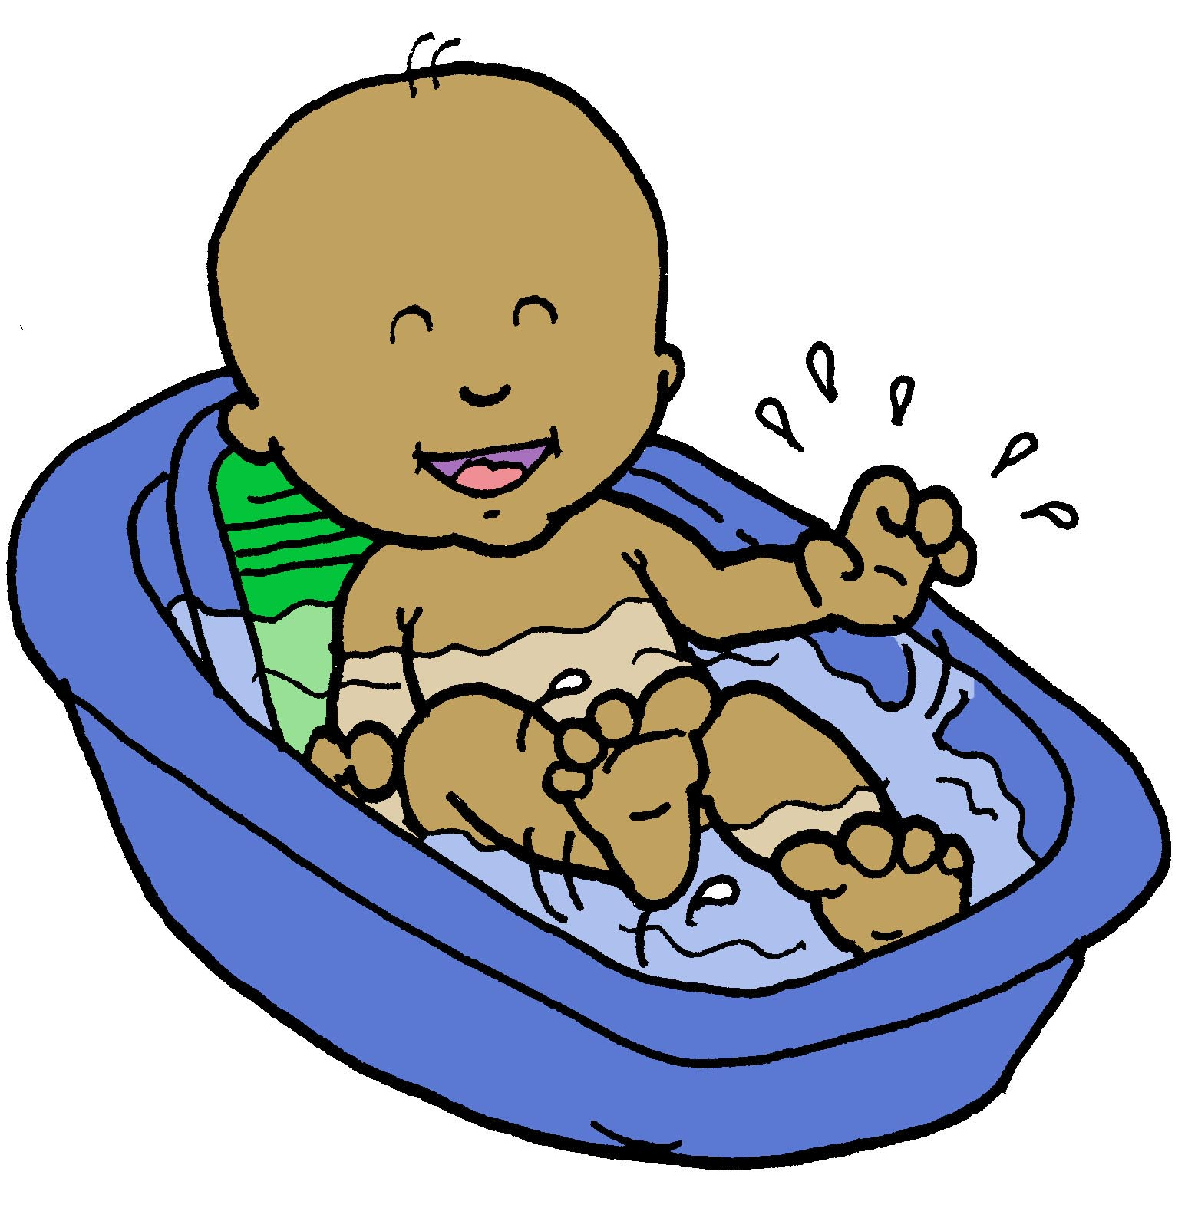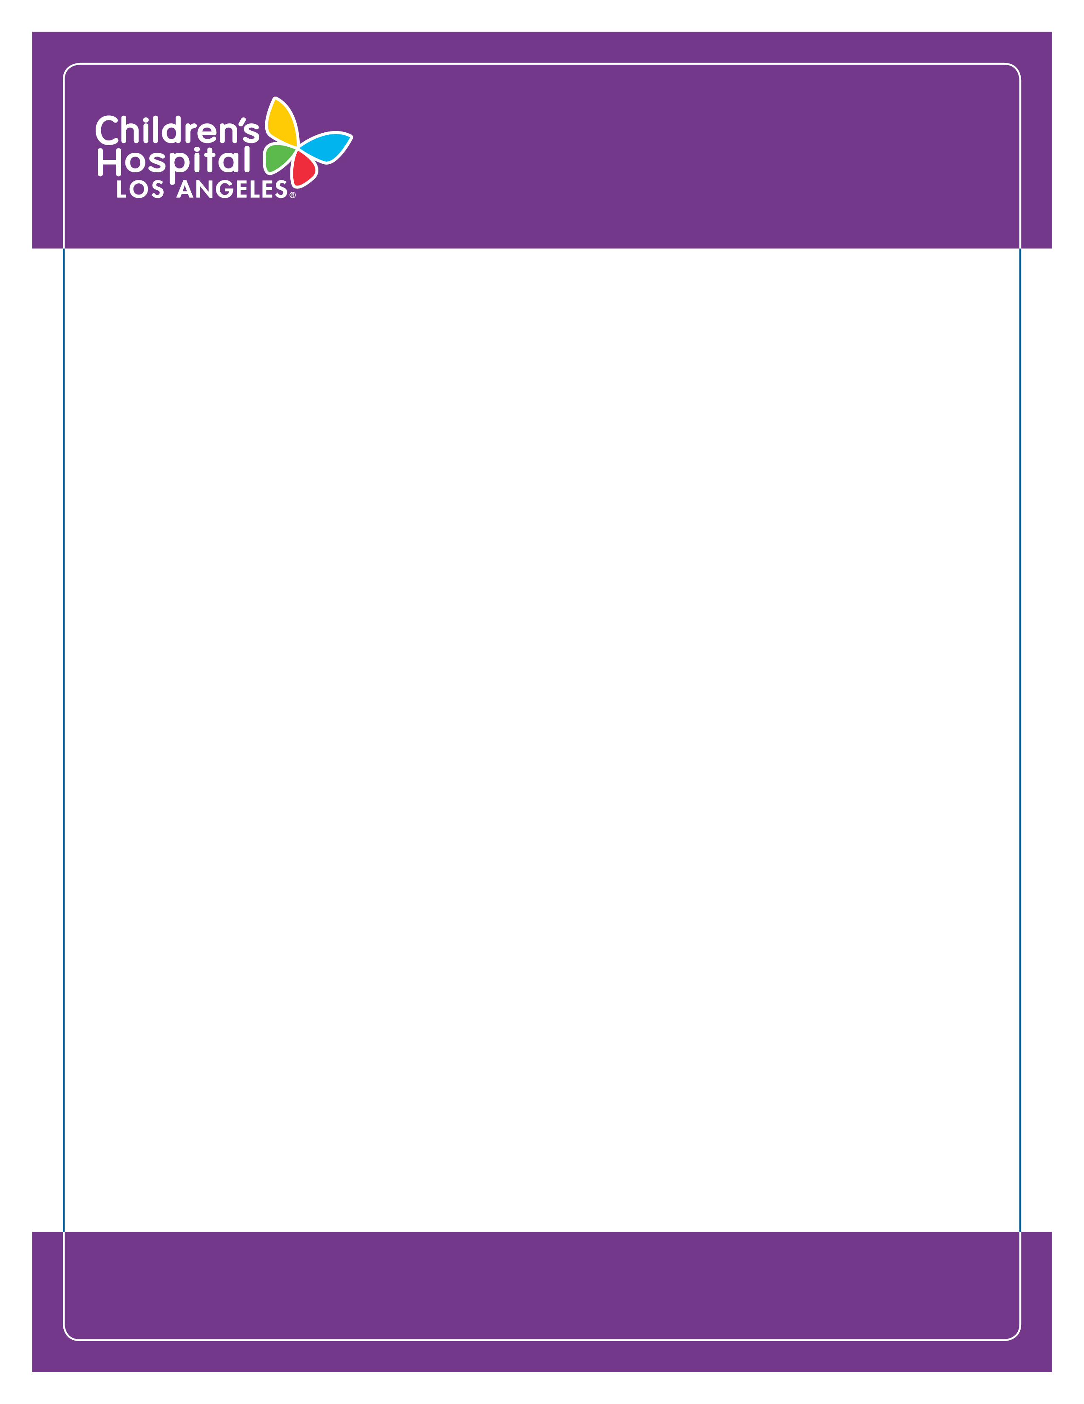

High-Risk Pre-operative

Bathing Instructions

Revised 02/06/2023

**Please follow the bathing instructions below:**

**Day Before Procedure:**

1. Have your child sleep on freshly washed bed sheets/linens.
2. Have your child bathe or shower with regular soap and wash their hair with regular shampoo.
3. Use a clean wash cloth to scrub the skin. Do not use a loofa or any reusable bath sponge since it can carry germs.
4. Do not shave the area of the body where the surgery will be performed.
5. Rinse your child well and remove all soap.
6. Use a clean, soft towel to pat your child’s body dry.
7. Put on clean clothes or pajamas.
8. Please do not put on any lotions, deodorants, perfumes or powders.
9. For children with long hair, put hair in 2 loose braids that will fall over the ears.

**Day of Procedure:**

On the day of the scheduled procedure, your child will have a bath with Chlorhexidine gluconate (CHG) in the surgical admitting area. CHG is a solution that fights bacteria and helps prevent infection related to surgery. If your child has a known CHG allergy, please let the nurse know.

The Surgical Admitting nurse will:

* Wipe your child’s skin with CHG wipes.
* Have your child put on a hospital gown before going to the Operating room.

**Please contact your child’s clinic for any questions or concerns.**

* **H** **h-Risk Pre-operative**

**Bathing Instructions**